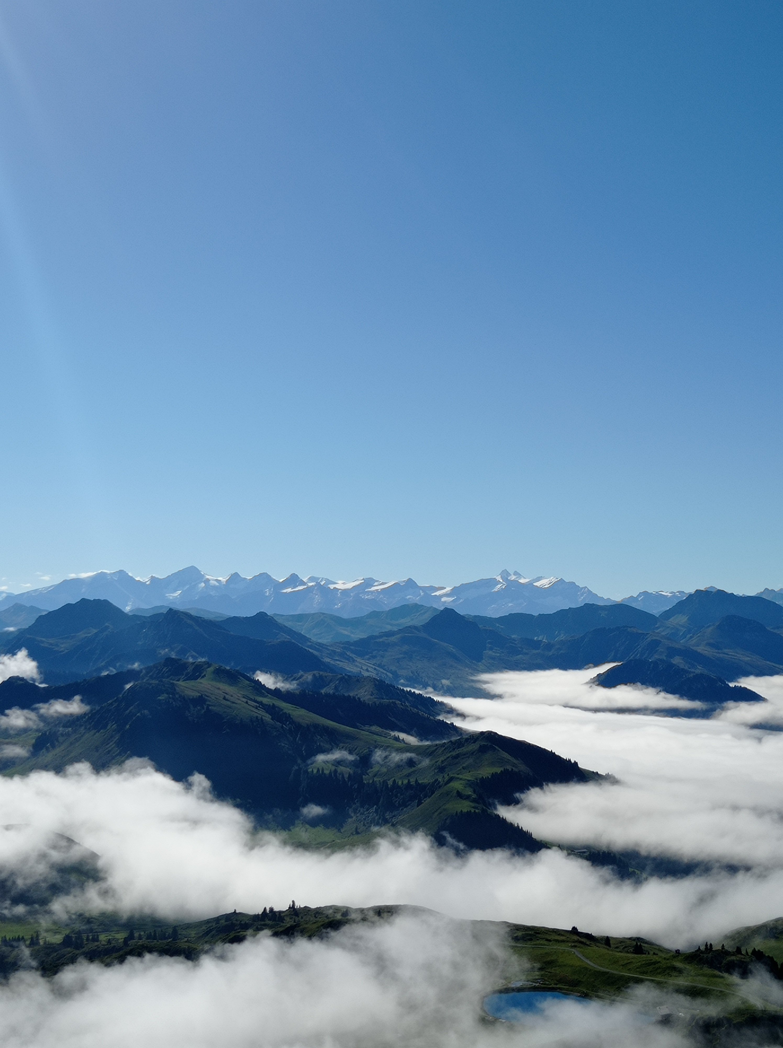
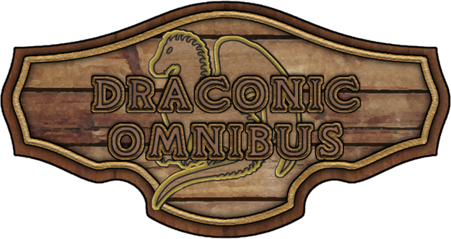

Silver Dragon
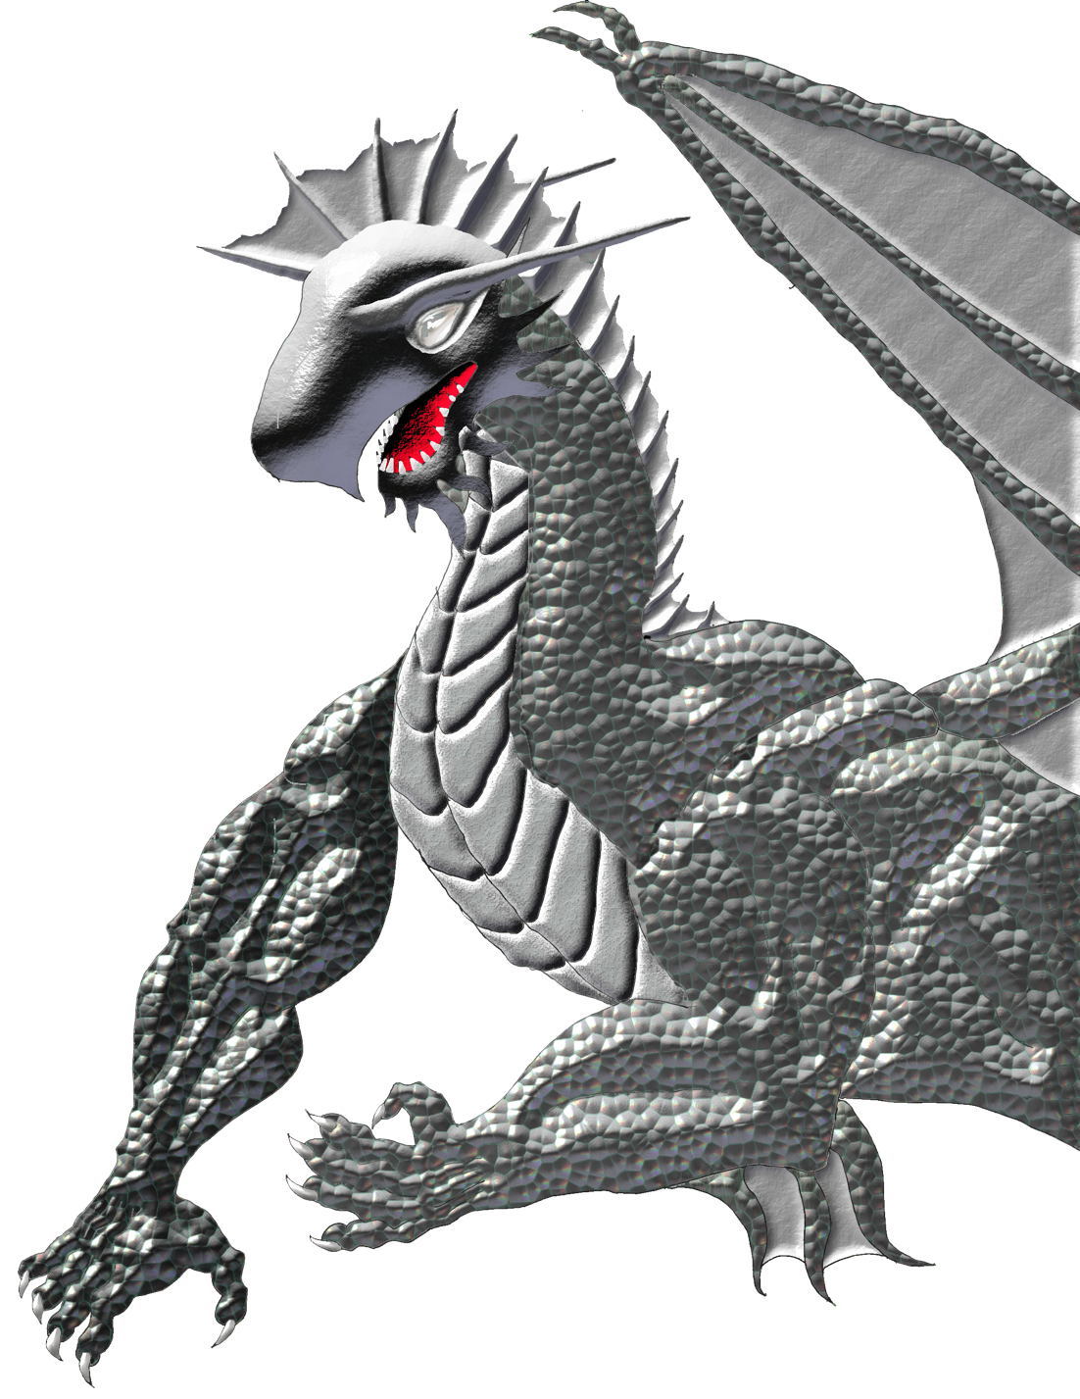
Draconic Omnibus, Vol. 2
Divided Continent Supplement

Silver Dragons in Caphora
This supplement was designed to accompany the corresponding Draconic Omnibus supplement, available on the DM’s Guild, but it can also be used with just the information in official publications from Wizards of the Coast.
This supplement provides specific information about Silver Dragons on Caphora: the Divided Continent campaign setting, available as a free download at wyrmworkspublishing.com.

Known Dragons

Chazarth the Kind
The most well-known silver dragon on Caphora is Chazarth the Kind of Anacal, an adult silver dragon, who helped repel the giant attack in 528. Chazarth is believed to still be in regular communication with the Anacali ruling family and often comes to the aid of those in need in the mountains.

Amys, The Gifted
Amys lives in the Great Spine Mountains with her husband and three wyrmlings, often visiting the mountain elf, aarakocra, and dwarf settlements in the area, sometimes for years at a time.

Common Locations
Silver dragons live in the mountains, so others have been sighted in the Great Spine Mountains, but the Lonely Mountains are believed to have the highest concentration of them, although the thick mist prevents population estimates.
Some claim to have seen a silver dragon in the Scarlet Peaks in battle with the reds that live there, but that was decades ago, and none have been seen since.

Deity Connections
Silver dragons follow all of the Lords of Light, varying in emphasis by specific dragon temperament, although all feel an affinity to Agape and have cleric allies among their friends.

Critical Success
While D&D can be played using any style the party likes, my campaign world was built for a purpose: to give hope and connection through multigenerational relationships. We accomplish this through the Critical Success strategy. Learn more about this strategy by following our Critical Success blog series at http://wyrmworkspublishing.com/critical-success-giving-players-every-advantage/

Draconic Omnibus
Because of licensing requirements, the Draconic Omnibus series is published in different locations. If you’d like all of them and to get notifications of new entries, sign up at http://wyrmworkspublishing.com/tag/draconic-omnibus/.
You can also find import files for the Game Master 5 app by Lion’s Den there.

Divided Continent Campaign Setting (Free)
Download the entire Caphora: The Divided Continent Campaign Setting FREE at http://wyrmworkspublishing.com/dungeons-dragons-campaign-world-caphora-the-divided-continent-introduction/

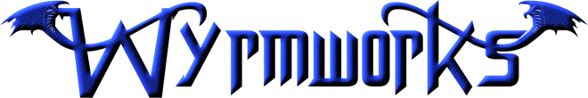
Credits & Copyright
- This work is licensed under a Creative Commons Attribution-NonCommercial-ShareAlike 4.0 International License by Wyrmworks Publishing.
- Lead writer, editor & developer: Dale Critchley
All of the stats contained here are also available in the Homebrew section of DNDBeyond.com so you can easily include them in your game.
This work is the combined effort of many sources and resources.
I’m indebted to my fellow Game Masters: Dylan Michienzi, Colin Eral, Richard Mahle, and Scott Volltrauer. You guys are an ongoing source of encouragement, joy, and creativity.
I used countless tools for this work. Here’s an incomplete list:
- Roll for Fantasy
- Donjon
- Tetra-Cube Stat Block Generator
- Some artwork created by Portrait Workshop by Worldspinner LLC
- Azgaar’s Fantasy Map Generator
- Tavern Sign Crafter by Justin Andrew Mason

TreeHouse
If you find this sourcebook useful, I’d appreciate you making donations to one of my favorite charities, TreeHouseHope.org. 100% of proceeds toward this book get donated to them. Their goal is to eliminate hopelessness from every teen. They have dozens of locations around the country and are growing, and in the work I’ve done with them, I get to see the lives of teens improved.
Even more than donations, I want to encourage you to seek out a local location for the teens you know (or for yourself if you’re a teen) and get involved, or if they don’t have a location near you, to launch a partner location.

Changelog
- December 20, 2020: Initial Release to DriveThruRPG
This campaign world is an ongoing work in progress, a labor of love, by Dale Critchley. If you’d like updates, subscribe free at wyrmworkspublishing.com or follow me on Twitter @risenwithchrist.

Legal
Permission to copy, modify and distribute this document is granted solely through the use of the Open Gaming License, Version 1.0a. The contents of this document are Open Game Content as described in Section 1(d) of the License. This material is being released using the Open Gaming License Version 1.0a and you should read and understand the terms of that license before using this material. The text of the Open Gaming License itself is not Open Game Content. Instructions on using the License are provided within the License itself. More information on the Open Game License can be found at www.wizards.com/d20. Additionally, please refer to US Copyright Law, Title 17 (October, 2009) for details (http://www.copyright.gov/title17/).
OPEN GAME LICENSE V1.0a
The following text is the property of Wizards of the Coast, Inc. and is Copyright 2000 Wizards of the Coast, Inc (“Wizards”). All Rights Reserved.
1. Definitions: (a)"Contributors" means the copyright and/or trademark owners who have contributed Open Game Content; (b)"Derivative Material" means copyrighted material including derivative works and translations (including into other computer languages), potation, modification, correction, addition, extension, upgrade, improvement, compilation, abridgment or other form in which an existing work may be recast, transformed or adapted; (c) "Distribute" means to reproduce, license, rent, lease, sell, broadcast, publicly display, transmit or otherwise distribute; (d)"Open Game Content" means the game mechanic and includes the methods, procedures, processes and routines to the extent such content does not embody the Product Identity and is an enhancement over the prior art and any additional content clearly identified as Open Game Content by the Contributor, and means any work covered by this License, including translations and derivative works under copyright law, but specifically excludes Product Identity. (e) "Product Identity" means product and product line names, logos and identifying marks including trade dress; artifacts; creatures characters; stories, storylines, plots, thematic elements, dialogue, incidents, language, artwork, symbols, designs, depictions, likenesses, formats, poses, concepts, themes and graphic, photographic and other visual or audio representations; names and descriptions of characters, spells, enchantments, personalities, teams, personas, likenesses and special abilities; places, locations, environments, creatures, equipment, magical or supernatural abilities or effects, logos, symbols, or graphic designs; and any other trademark or registered trademark clearly identified as Product identity by the owner of the Product Identity, and which specifically excludes the Open Game Content; (f) "Trademark" means the logos, names, mark, sign, motto, designs that are used by a Contributor to identify itself or its products or the associated products contributed to the Open Game License by the Contributor (g) "Use", "Used" or "Using" means to use, Distribute, copy, edit, format, modify, translate and otherwise create Derivative Material of Open Game Content. (h) "You" or "Your" means the licensee in terms of this agreement.
2. The License: This License applies to any Open Game Content that contains a notice indicating that the Open Game Content may only be Used under and in terms of this License. You must affix such a notice to any Open Game Content that you Use. No terms may be added to or subtracted from this License except as described by the License itself. No other terms or conditions may be applied to any Open Game Content distributed using this License.
3.Offer and Acceptance: By Using the Open Game Content You indicate Your acceptance of the terms of this License.
4. Grant and Consideration: In consideration for agreeing to use this License, the Contributors grant You a perpetual, worldwide, royalty­free, non­exclusive license with the exact terms of this License to Use, the Open Game Content.
5.Representation of Authority to Contribute: If You are contributing original material as Open Game Content, You represent that Your Contributions are Your original creation and/or You have sufficient rights to grant the rights conveyed by this License.
6.Notice of License Copyright: You must update the COPYRIGHT NOTICE portion of this License to include the exact text of the COPYRIGHT NOTICE of any Open Game Content You are copying, modifying or distributing, and You must add the title, the copyright date, and the copyright holder's name to the COPYRIGHT NOTICE of any original Open Game Content you Distribute.
7. Use of Product Identity: You agree not to Use any Product Identity, including as an indication as to compatibility, except as expressly licensed in another, independent Agreement with the owner of each element of that Product Identity. You agree not to indicate compatibility or co­adaptability with any Trademark or Registered Trademark in conjunction with a work containing Open Game Content except as expressly licensed in another, independent Agreement with the owner of such Trademark or Registered Trademark. The use of any Product Identity in Open Game Content does not constitute a challenge to the ownership of that Product Identity. The owner of any Product Identity used in Open Game Content shall retain all rights, title and interest in and to that Product Identity.
8. Identification: If you distribute Open Game Content You must clearly indicate which portions of the work that you are distributing are Open Game Content.
9. Updating the License: Wizards or its designated Agents may publish updated versions of this License. You may use any authorized version of this License to copy, modify and distribute any Open Game Content originally distributed under any version of this License.
10. Copy of this License: You MUST include a copy of this License with every copy of the Open Game Content You Distribute.
11. Use of Contributor Credits: You may not market or advertise the Open Game Content using the name of any Contributor unless You have written permission from the Contributor to do so.
12. Inability to Comply: If it is impossible for You to comply with any of the terms of this License with respect to some or all of the Open Game Content due to statute, judicial order, or governmental regulation then You may not Use any Open Game Material so affected.
13. Termination: This License will terminate automatically if You fail to comply with all terms herein and fail to cure such breach within 30 days of becoming aware of the breach. All sublicenses shall survive the termination of this License.
14. Reformation: If any provision of this License is held to be unenforceable, such provision shall be reformed only to the extent necessary to make it enforceable.
15. Open Game License v 1.0a Copyright 2000, Wizards of the Coast, LLC. Draconic Omnibus, Vol. 2: Silver Dragon, Divided Content Supplement ©2020 Wyrmworks Publishing; Author Dale Critchley

